**CDA3315C Revised Appendix for Labs**

Table of Contents

**APPENDIX A** 2

**SETUP AND INSTALL APP SERVICE W/MYSQL** 2

**APPENDIX B** 3

**CREATE A NEW MYSQL DATBASE TABLE** 3

**APPENDIX C** 4

**BUILD NEW REPORTING TABLE AND LOAD DATA** 4

**APPENDIX D** 5

**CREATE A NEW PHP WEB PAGE FILE** 5

**APPENDIX E** 7

**CREATE A PHP CONNECTION STRING** 7

**APPENDIX F** 10

**WRITE PHP AND PROCESS DATABASE ACTIVITY** 10

**APPENDIX G** 12

**WRITE CSS3 SYNTAX TO FORMAT WEB PAGE** 12

**APPENDIX H** 14

**PUBLISH PHP FILE TO CLOUD WEB APP SERVICE** 14

**APPENDIX I** 20

**PREVIEW PHP WEBSITE IN CHROME DEVELOPER MODE** 20

**APPENDIX A**

**SETUP AND INSTALL APP SERVICE W/MYSQL**

1. Login to open.azure.com
2. In the top left hand corner click on the + Create a resource.
3. Search for new service “Web App + MySQL” and press enter.
   1. Click on Web App + MySQL
   2. Select Create
   3. Give the service a unique Web App Name (Make note of it).
   4. Choose create a new Resource Group
   5. Give the resource group a name if it does not autopopulate.
   6. Ensure the Database Provider says “Azure Database for MySQL”.
   7. Click on Database
   8. If the Server Name and Server Admin login name do not autopopulate fill these in.
   9. (Make a note of the Server Name and the Server Admin login name)
   10. Enter a complex password twice. (Make note of it).
   11. If the database name does not autopopulate enter a name for the database.
   12. (Make a note of the database name).
   13. Click OK
   14. Check the Pin to Dashboard checkbox
   15. Select Create
4. Wait a little bit until Azure creates the two resources.
5. When the two resources are created, the Web App Console should open. If not Click on the Web App Square on your Azure dashboard.
6. Scroll down on the left a ways. Under Development Tools you will see Extensions
   1. Click Extensions
   2. Click the + Add at the top
   3. Scroll all the way to the bottom until you see phpMyAdmin
   4. Click on phpMyAdmin
   5. Click Ok > Click Ok
   6. Wait 1 or 2 minutes

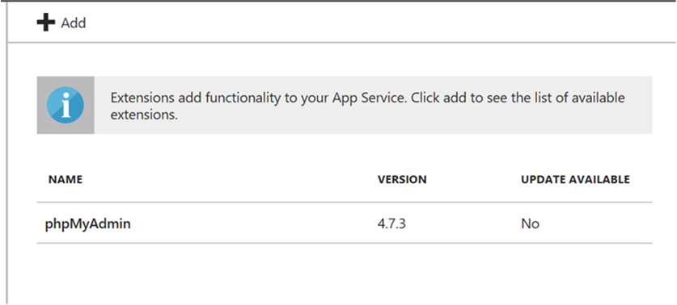

1. Connect to phpMyAdmin
   1. Click on the new phpMyAdmin extension
   2. Click on browse
   3. You should see your MySQL database on the left hand side
2. Done

**APPENDIX B**

**CREATE A NEW MYSQL DATBASE TABLE**

1. Login to portal.azure.com
2. Select Extensions > phpMyAdmin extension > Select Browse
3. phpMyAdmin will be displayed in the browser and you should be automatically logged in.
4. Left click on your database name in the left menu to select it
5. Click on SQL in the top menu
6. We will now run SQL and create a new database table called “tblCDA3315C”
   1. Copy/Paste SQL below into Query box

CREATE TABLE tblCDA3315C

(ID INT NOT NULL AUTO_INCREMENT,

PRIMARY KEY(ID),

FIRST_NAME VARCHAR(30),

LAST_NAME VARCHAR(30),

TELEPHONE VARCHAR(30))

1. Click on the GO button located near the bottom middle right side.
2. You should see the “tblCDA3315C” table in the database folder on the left
3. Done

**APPENDIX C**

**BUILD NEW REPORTING TABLE AND LOAD DATA**

1. Activate the phpMyAdmin extension as you have done previously through the Azure Web App.
2. Select your database on the left.
3. Click on SQL at the top.
4. We will now create a new table called “tblUSERS”. Copy the following query into the SQL window and click Run.

CREATE TABLE tblUSERS (USERS_ID INT NOT NULL AUTO_INCREMENT, PRIMARY KEY(USERS_ID), FIRST_NAME VARCHAR(30), LAST_NAME VARCHAR(30), MIDDLE_NAME VARCHAR(30), TELEPHONE VARCHAR(30), FAX_NUMBER VARCHAR(30), STATUS VARCHAR(1), CREATED_BY VARCHAR(30), CREATED_DATE DATE, MODIFIED_BY VARCHAR(30),

MODIFIED_DATE DATE)

1. Run the new query below to create a new table called “tblADDRESSES”

CREATE TABLE tblADDRESSES (ADDR_ID INT NOT NULL AUTO_INCREMENT, PRIMARY KEY(ADDR_ID),

USERS_ID INT, ADDRESS1 VARCHAR(30), ADDRESS2 VARCHAR(30), CITY VARCHAR(30), STATE VARCHAR(30),

ZIPCODE INT, STATUS VARCHAR(1), CREATED_BY VARCHAR(30), CREATED_DATE DATE, MODIFIED_BY VARCHAR(30),

MODIFIED_DATE DATE)

1. Run the new query below to insert a new record into the tblUSERS table

[INSERT](https://webappmysqlras.scm.azurewebsites.net/phpmyadmin/url.php?url=https://dev.mysql.com/doc/refman/5.5/en/insert.html) INTO tblusers (USERS_ID, FIRST_NAME, LAST_NAME, MIDDLE_NAME, TELEPHONE, STATUS, CREATED_BY, CREATED_DATE, MODIFIED_BY, MODIFIED_DATE) [VALUES](https://webappmysqlras.scm.azurewebsites.net/phpmyadmin/url.php?url=https://dev.mysql.com/doc/refman/5.5/en/miscellaneous-functions.html#function_values) (1, 'JOHN', 'DOE', 'LITE', '123-456-7890', 'A', 'STUDENT', CURDATE(), 'STUDENT', CURDATE())

1. Run the new query below to insert a new record into the tblADDRESSES table

INSERT INTO `tbladdresses`(`ADDR_ID`, `USERS_ID`, `ADDRESS1`, `ADDRESS2`, `CITY`, `STATE`, `ZIPCODE`, `STATUS`, `CREATED_BY`, `CREATED_DATE`, `MODIFIED_BY`, `MODIFIED_DATE`) VALUES (1, 1, '1700 Clean Ave.', 'n/a' , 'TOPEKA', 'FL.', '10011', 'A', 'DEAN',CURDATE(), 'DEAN',CURDATE() )

1. Run the following query to verify that the tables can talk to each other

SELECT tblB.FIRST_NAME, tblB.LAST_NAME, tblB.TELEPHONE, tblA.ADDRESS1, tblA.CITY, tblA.STATE, tblA.ZIPCODE

FROM tbladdresses tblA JOIN tblusers tblB ON tblB.users_id = tblA.users_id

WHERE tblB.USERS_ID = 1 AND tblA.STATUS = 'A' AND tblB.STATUS = 'A'

1. Results from the query

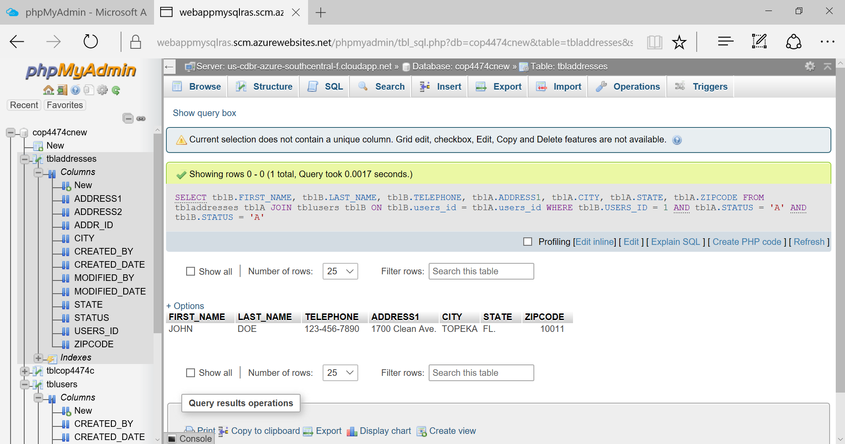

1. Done

**APPENDIX D**

**CREATE A NEW PHP WEB PAGE FILE**

1. Right click on the Desktop > Select New > Select Text Document
2. Change the file name to “index.php” > Press Enter
   1. Make sure the file type is “php” and not “txt”
3. Open the file index.php in Notepad.exe
4. Create an HTML5 web page template using this sample code:

<!DOCTYPE html>  
<html>

<head>

<title>Registration Form</title>

<!-- Bootstrap Reference Links -->

<link rel="stylesheet" href="https://maxcdn.bootstrapcdn.com/bootstrap/3.3.7/css/bootstrap.min.css">

<script src="https://ajax.googleapis.com/ajax/libs/jquery/3.2.1/jquery.min.js"></script>

<script src="https://maxcdn.bootstrapcdn.com/bootstrap/3.3.7/js/bootstrap.min.js"></script>

<!-- End of Bootstrap References -->

</head>  
<body>  
<div id="Div1" class="col-sm-4">  
<h1>Rasmussen Registration Form</h1>  
<p>Fill in your name and telephone, then click <strong>Submit</strong> to register.</p>

<form method="post" action="index.php" enctype="multipart/form-data" >

FIRST_NAME <input type="text" name="first_name" id="first_name"/></br>

LAST_NAME <input type="text" name="last_name" id="last_name"/></br>

TELEPHONE <input type="text" name="telephone" id="telephone"/></br>

<input type="submit" id="submit1" value="Submit" />

</form>

<?php

?>

<div>

</body>  
</html>

1. Copy and Paste the HTML sample into the index.php file > Save the file
2. Preview the sample code in the Google Chrome browser
   1. It should look similar to this:

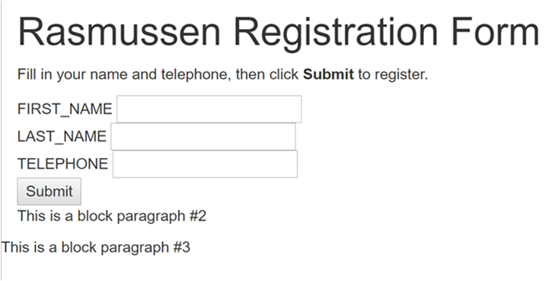

1. Done

**APPENDIX E**

**CREATE A PHP CONNECTION STRING**

1. Open the course index.php file in Notepad.exe
2. Copy and paste the PHP syntax connection string inside the php tags (e.g. <?php ?>)

// DB connection info

// Within the PHP tags, add PHP code for connecting to the database.

$host = "Put App Service URL Here ";

$user = "Put DB UserID Here";

$pwd = "Put DB Password Here";

$db = "Put Database Name Here";

1. Update the $host variable value with your Azure Database for MySQL server URL.
   1. Go to the student cloud portal and select the Azure Database for MySQL server
   2. Select the Overview
   3. Get a copy of the Azure Database for MySQL server “Server name” URL
   4. Use what you just copied to replace “Put App Service URL Here” (do not delete the double quotes) in the php script you just added to index.php.

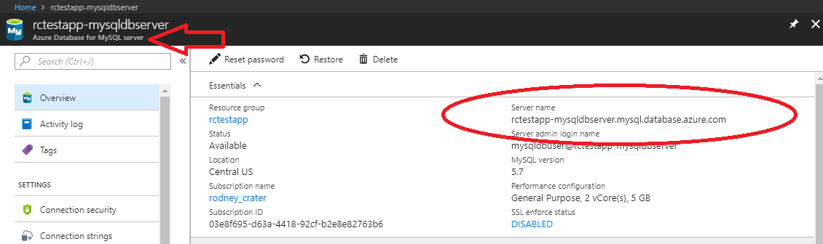

1. Update the $user variable value with your Azure Database for MySQL server admin name.
   1. While you are still viewing the control panel for your Azure Database for MySQL
   2. Make sure Overview is still selected
   3. Get a copy of the Azure Database for MySQL server “Server admin login name”
   4. Use what you just copied to replace "Put DB UserID Here" (do not delete the double quotes) in the php script you just added to index.php.

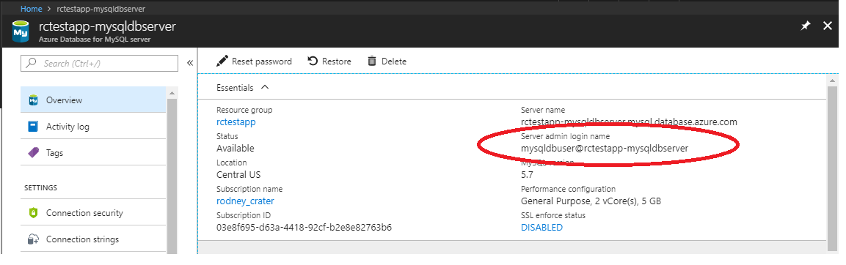

1. Update the $pwd variable value with your Azure Database for MySQL server admin password.
2. Replace " Put DB Password Here" (do not delete the double quotes) in the php script with the actual server admin password.
3. If you have forgotten the password you can reset it at the top of the Overview (see graphic below).

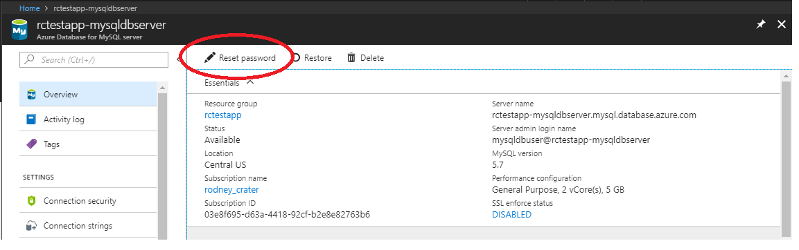

1. Update the $db variable value with your Azure Database for MySQL database name.
2. While you are still viewing the control panel for your Azure Database for MySQL
3. Make sure Overview is still selected
4. Scroll down the Overview view until you see Databases
5. Highlight and copy of your database name (do not use the one shown in the graphic below)
6. Use what you just copied to replace "Put Database Name Here " (do not delete the double quotes) in the php script you just added to index.php.

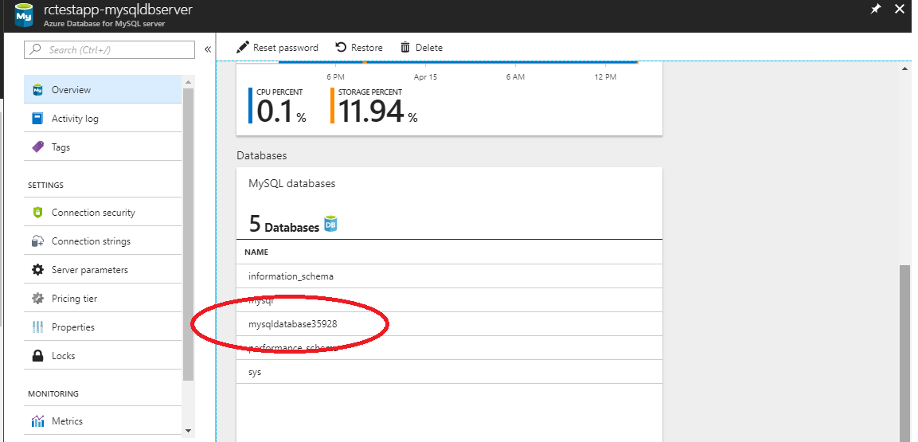

1. Save index.php
2. Preview the sample code in the Google Chrome browser
3. Simply make sure you do not have any errors
4. You will not be able to preview the PHP syntax with a browser
5. The PHP will not work until the index.php file is published on a web hosting server that supports PHP
6. Done

**APPENDIX F**

**WRITE PHP AND PROCESS DATABASE ACTIVITY**

1. Open the course index.php file in Notepad.exe
2. Write PHP to connect to the MySQL database service
3. Copy the following PHP syntax.
4. Paste it under the php variable code you just entered/updated in Appendix E.

(This following code is used to allow index.php to connect to your database.

// Connect to database.

try {

$conn = new PDO( "mysql:host=$host;dbname=$db", $user, $pwd);

//$conn->setAttribute( PDO::ATTR_ERRMODE, PDO::ERRMODE_EXCEPTION );

}

catch(Exception $e){

die(var_dump($e));

}

1. Copy and paste the following PHP syntax below the database connection code you just inserted into index.php.

(This code will to insert a new record into the tblCSA3315C table using the information that a user types into the web page form. Notice the SQL code below that follows $sql_insert= is the same as what you might use in the phpMyAdmin SQL window).

//Code for inserting registration information into the tblCSA3315C table in the database

if(!empty($_POST)) {

try {

//retrieve data sent from the web page form fields and place into php variables

$first_name = $_POST['first_name'];

$last_name = $_POST['last_name'];

$telephone = $_POST['telephone'];

// Insert data into the tblCDA3315C table

$sql_insert = "INSERT INTO tblCDA3315C(FIRST_NAME, LAST_NAME, TELEPHONE)

VALUES (?,?,?)";

$stmt = $conn->prepare($sql_insert);

$stmt->bindValue(1, $first_name);

$stmt->bindValue(2, $last_name);

$stmt->bindValue(3, $telephone);

$stmt->execute();

}

catch(Exception $e) {

die(var_dump($e));

}

echo "<h3>You're Registered!</h3>";

}

1. Copy and paste the following PHP syntax under the query code you just pasted into index.php.

(This code will send a query to retrieve data from the database service. The database will return the results to the app service. The app service will then stream back the results of the query and place the results into the web page).

//Finally, following the code above, add code for retrieving data from the database.

$sql_select = "SELECT * FROM tblCDA3315C";

$stmt = $conn->query($sql_select);

$registrants = $stmt->fetchAll();

if(count($registrants) > 0) {

echo "<h2>People Who Are Registered:</h2>";

echo "<table boarder=2>";

echo "<tr><th style='width:300px'>FIRST_NAME</th>";

echo "<th style='width:300px'>LAST_NAME</th>";

echo "<th>TELEPHONE</th></tr>";

foreach($registrants as $registrant) {

echo "<tr><td>".$registrant['FIRST_NAME']."</td>";

echo "<td>".$registrant['LAST_NAME']."</td>";

echo "<td>".$registrant['TELEPHONE']."</td></tr>";

}

echo "</table>";

} else {

echo "<h3>No one is currently registered.</h3>";

}

1. Preview the sample code in the Google Chrome browser
   1. At this point, you may expperience several errors since the browser is trying to connect to the database service
   2. This is normal and for now, try to ignore the errors
2. Done

**APPENDIX G**

**WRITE CSS3 SYNTAX TO FORMAT WEB PAGE**

1. Open the course index.php file in Notepad.exe
2. Write a new <Script> tag in the index.php file
   1. Inside the <head> tag, under <!-- End of Bootstrap References --> but before the closing </head> tag, create a new open/closing set of script tags (e.g. <script> </script>)
3. Expand the opening and closing script tags so there are empty lines between them
4. Copy and paste the CSS wrapper class syntax between the script tags

.wrapper {

overflow: hidden;

}

1. Add a new wrapper <div> tag around the outside of the main <div> tags in the body of the index.php file
   1. This tag will wrap around all of the <div> tags and their content.

<div id="DivHeader" class="wrapper">

</div>

1. Copy and paste the CSS syntax to format support for different device screen sizes
   1. Make sure this CSS syntax is between the <script> tags

/*PHONE CSS */

@media screen and (min-width: 10px) and (max-width: 550px), (min-device-width: 10px) and (max-device-width: 550px) {

#Div1, #Div2, #Div3, #tblGrid {

border:2px solid black;

width:100%;

float:left;

font-size: 2em;

}

#first_name, #last_name, #telephone {

width: 100%;

border: 2px solid black;

}

#submit1 {

background-color: #ffff80;

}

}

/*TABLET CSS */

@media screen and (min-width: 551px) and (max-width: 900px), (min-device-width: 551px) and (max-device-width: 900px) {

#Div1, #Div2, #Div3 {

border:2px solid black;

width:100%;

float:left;

font-size: 4em;

}

#first_name, #last_name, #telephone {

width: 100%;

border: 2px solid black;

}

#submit1 {

background-color: #ccb3ff;

}

}

/*FULL SCREEN CSS */

@media screen and (min-width: 901px), (min-device-width: 901px){

body { background-color: #fff; border-top: solid 10px #000;

color: #333; font-size: .85em; margin: 20; padding: 20;

font-family: "Segoe UI", Verdana, Helvetica, Sans-Serif;

}

h1, h2, h3,{ color: #000; margin-bottom: 0; padding-bottom: 0; }

h1 { font-size: 2em; }

h2 { font-size: 1.75em; }

h3 { font-size: 1.2em; }

table { margin-top: 0.75em; boarder: 2px; }

th { font-size: 1.2em; text-align: left; border: none; padding-left: 0; }

td { padding: 0.25em 2em 0.25em 0em; border: 0 none; }

#Div2, #Div3 {

border:2px solid black;

float:left;

font-size: 4em;

}

#Div1 {

border:2px solid black;

float:left;

font-size: 4em;

width:100%;

}

}

1. Preview
2. Done

**APPENDIX H**

**PUBLISH PHP FILE TO CLOUD WEB APP SERVICE**

1. Go to student cloud portal account > Select Web App service w/MySQL
2. Select Deployment credentials option in the left menu

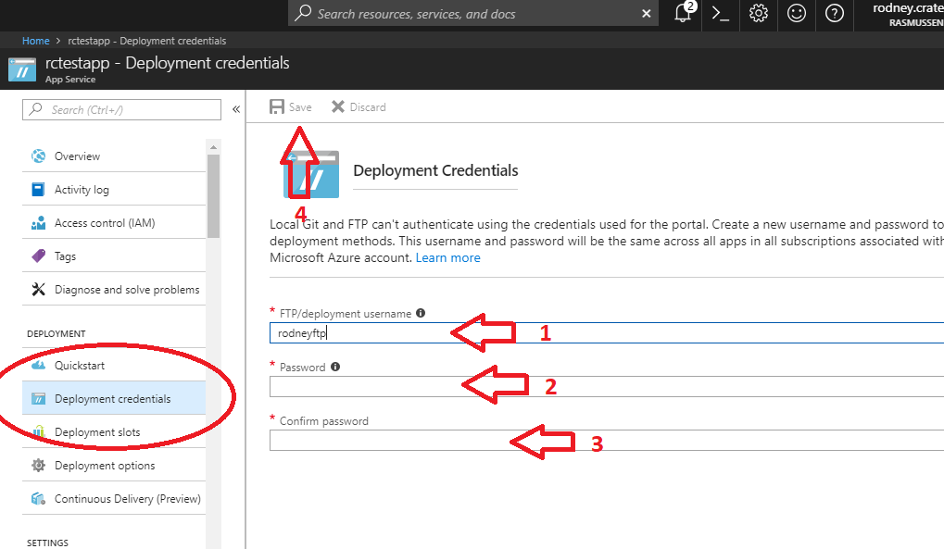

1. Enter a FTP username and password > then save in the top menu
2. Go out of the Deployment > Select Overview option

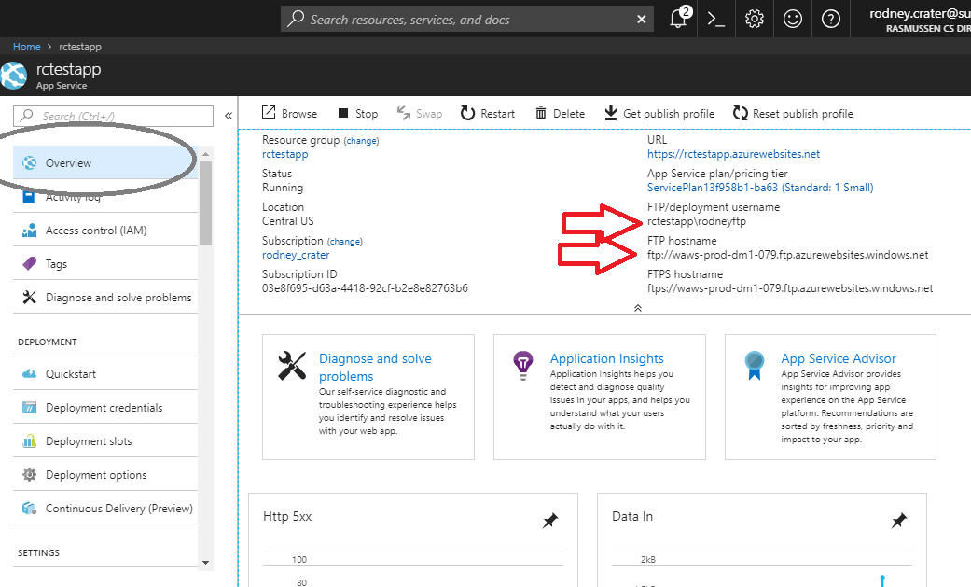

1. Note the FTP FTP/deployment username (you will need the first and last parts that are before and

after the slash \ , that is you will need the whole item shown)

1. Note the entire FTP hostname.

(continued next page)

---- FTP Client Option 1 ----

1. If you do not already have Filezilla Client go to <https://filezilla-project.org/> , download it, and install it. (Make sure to download the Client, not the Server)
2. Open the Filezilla Client and click on the icon at the top left.

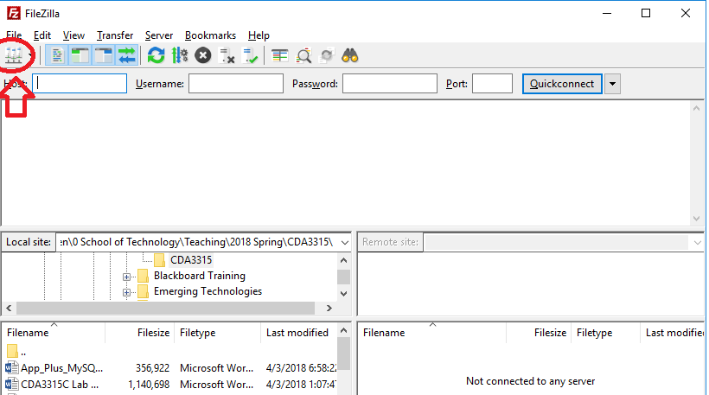

1. A new site manager window will open

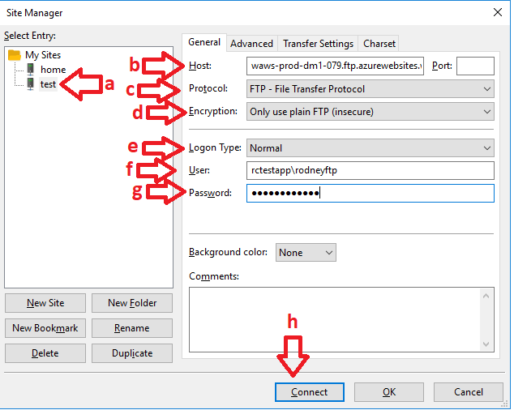

1. Fill in the following information:
   1. Give the connection a name that make sense
   2. Host will be your web app host name that you noted previously
   3. Set Protocol to FTP
   4. Set Encryption to Only use plain FTP
   5. Set Logon Type to Normal
   6. User will be the web app full user name you noted previously
   7. Password will be the password you entered for the FTP user previously
   8. When you have filled all the areas in, click Connect (the settings will be saved for next use and you will connect to your web app’s remote folders.

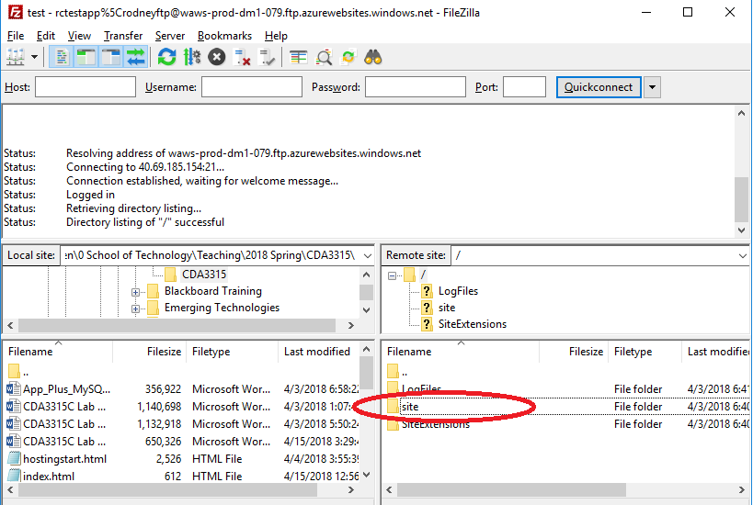

1. The lower left side shows the folders and files on your computer. The lower right shows the files and folder on the remote site (the web app folders).
2. Double click on the right folder that says site.

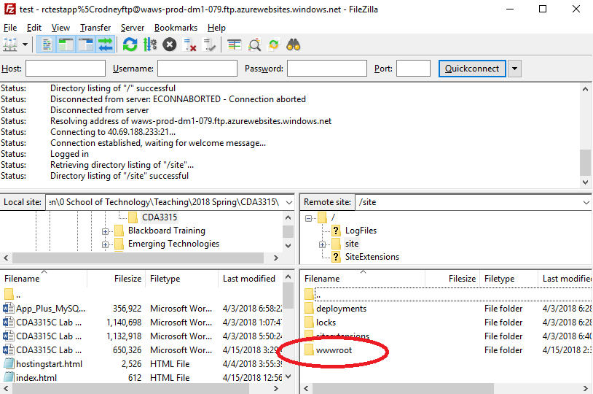

1. The subfolders in the site folder will now show. Double click on the right hand side folder that says wwwroot. This is the root of the web app’s web site. Files in the folder will show.
2. You will transfer a copy of the index.php file to the wwwroot folder.
3. On the LEFT hand side, navigate (drill up and down) until you reach the folder on your computer that has the index.php folder.

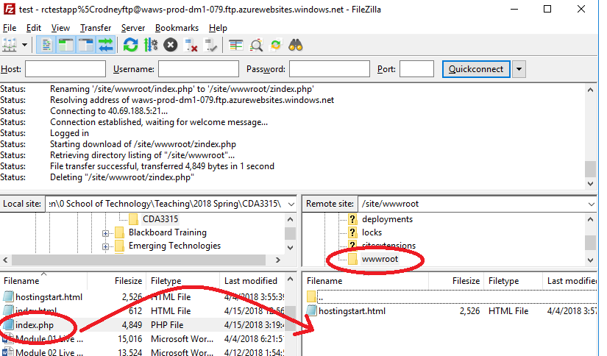

1. Double click on, drag and drop or, copy and paste the index.php file on the right hand side. This will cause a copy to transfer through the Internet to the folder on your remote web app.

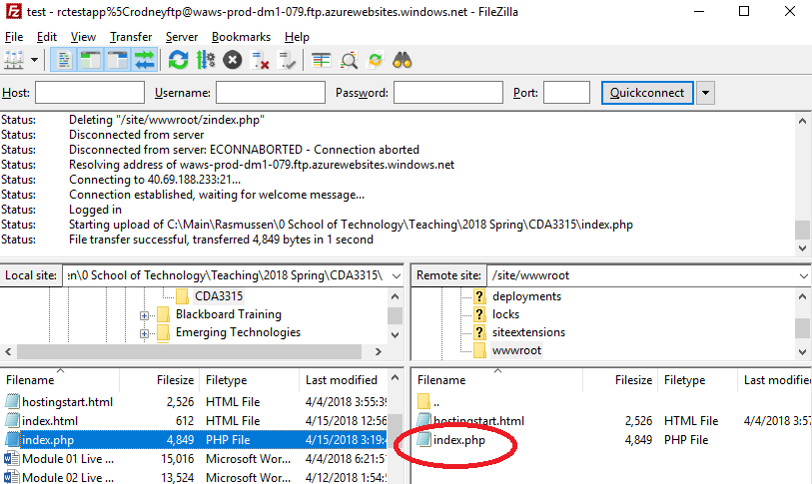

<<< End FTP Option 1 – If you used this skip Option 2 >>>

---- FTP Client Option 2 (Instead of FIlezilla Client) ----

1. Paste a copy of the FTP hostname URL into the address bar > press ENTER
2. You will then bet prompted for the FTP user and password credentials

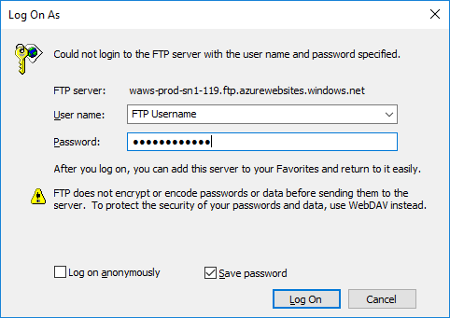

1. Get the FTP username from the Web App service Overview option
2. Get the FTP password from the Web App service Deployment credentials option
3. An FTP connection to the App Service will open and show three folders

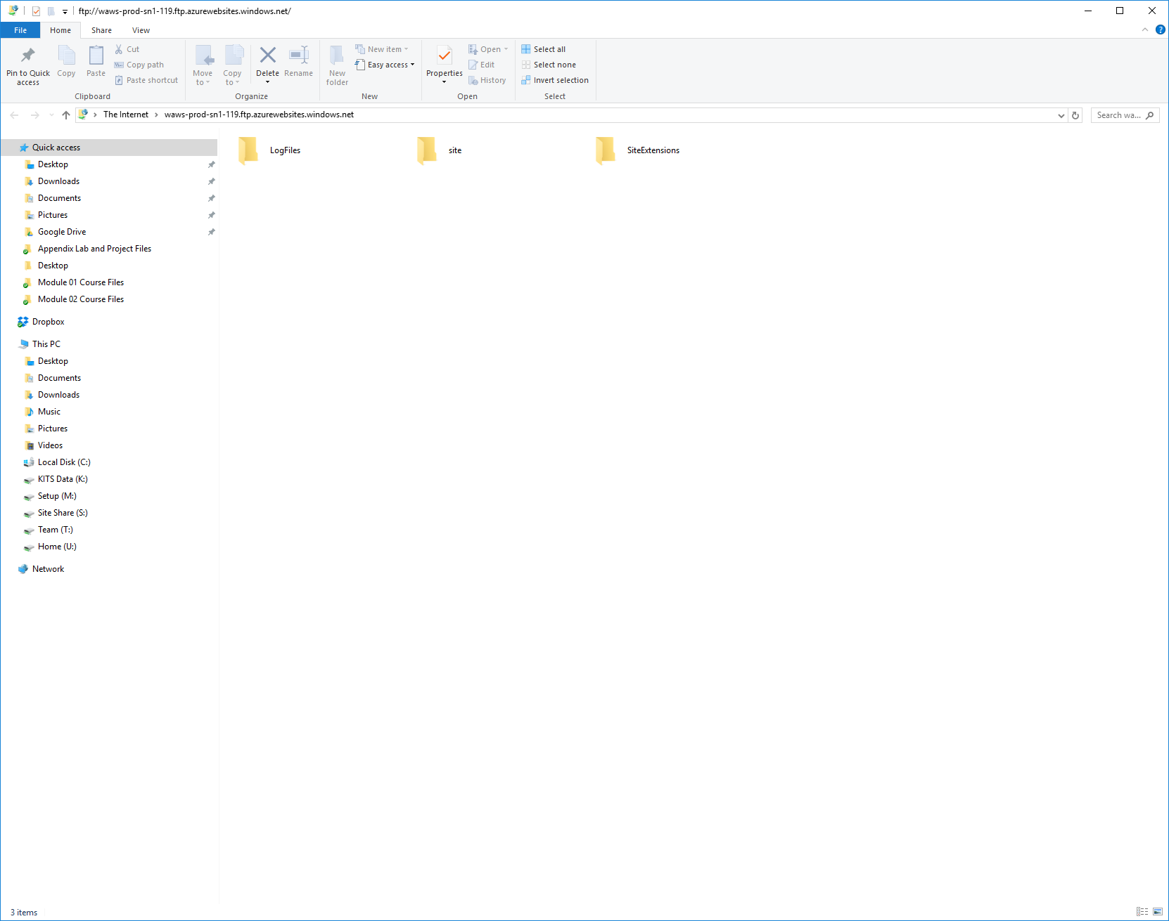

1. Select folder called “site” > Select folder called “wwwroot”
2. Copy and paste a copy of the index.php file into the “wwwroot” folder path

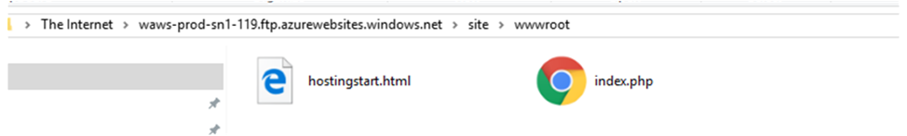

<<< End FTP Option 2 >>>

1. Go back to the Web App service > select Overview
2. Click on the Web App service URL
   1. It will open in a browser window

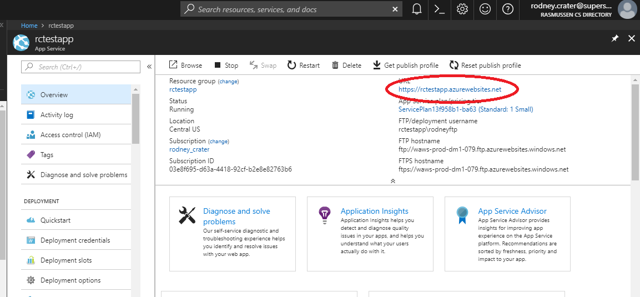

1. Preview the sample code in the Google Chrome browser ( paste url into address bar of Chrome if not default browser – If you do not have Chrome you will need to install it for next week’s labs )
   1. You should not have any errors
   2. The web app will connect to the database service once you press the submit button
   3. Test the app by adding information to the form then press the submit button
   4. You should get a “You’re Registered!” message
   5. The form information should populate below the form under “People Who Are Registered”

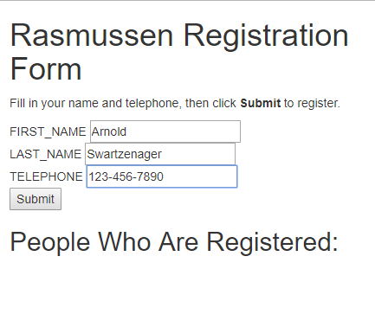

-------------------------------------------------------

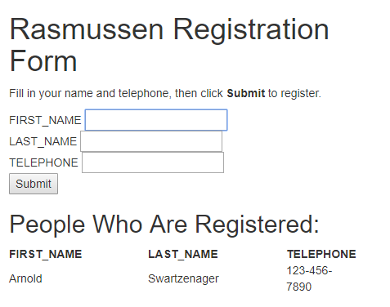

1. Done

**APPENDIX I**

**PREVIEW PHP WEBSITE IN CHROME DEVELOPER MODE**

1. Go to student cloud portal account > Select Web App service w/MySQL
2. Select Overview
3. Click on the Web App service URL
   1. It will open in a browser window
4. You might need to add /index.php at the end of the URL in the browser address bar
   1. http://app-service-url/index.php
5. Preview the web site page in a Google Chrome browser

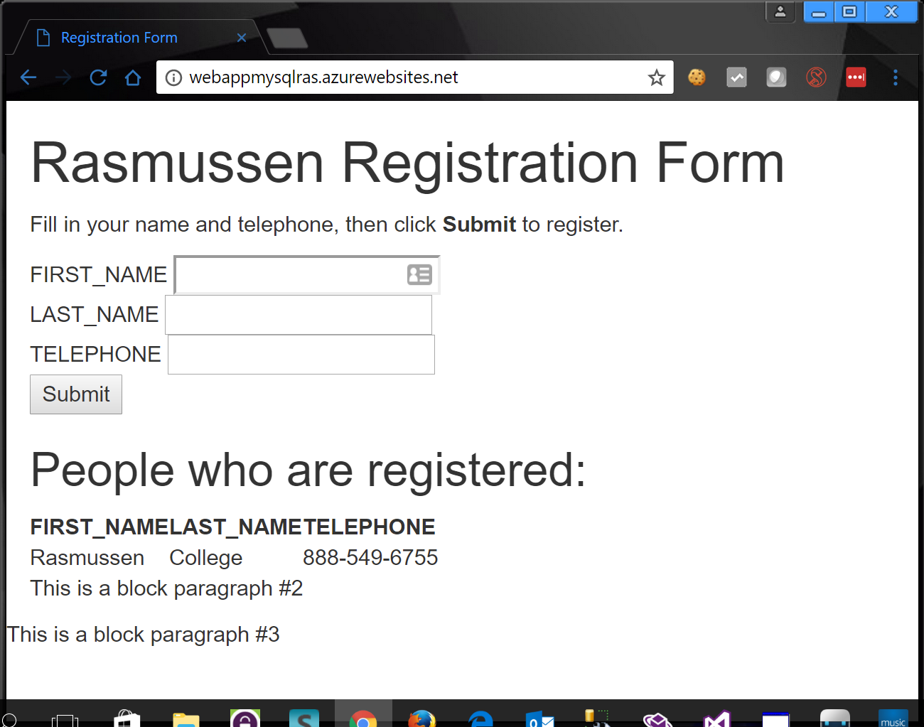

1. Add four new records to the database.
2. Use phpMyAdmin to verify the records in the database.
3. In the Google Chrome browser go to the top menu > select the button with three dots in the top right.
   1. This is the browser options dialog window.
4. Go to More Tools > Select Developer Tools

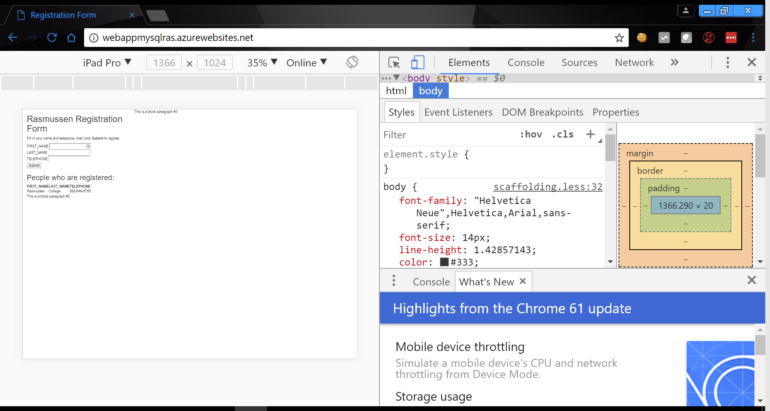

1. Change the menu device dropdown control to another device, like “Galaxy S5”
2. You will notice the left panel view changed to fit the size of device
3. This developer mode in Chrome let’s you see how your web site looks and feels to many different types of devices that are already configured within your Chrome browser
4. Done